
Lesson 8: Under Pressure
TIC-80
VIDEO GAME CREATION
This week: give the enemies you dodge last week actual stakes. An enemy reaching the bottom now costs a life - lose all 3, and "Game Over" appears.
Open your own [YourName]Game project from Lesson 7 - don't start a new one.
Tip: the core exercise needs no new assets - this reuses last week's escape-cleanup code and just gives it a real consequence. For Level 3 sound, use the provided sfx_lifelost.wav and sfx_gameover.wav from the Lesson 8 Assets folder.

Setup
- Launch TIC-80 and load your cart from Lesson 7.
- Press Esc to reach the code editor.

Level 1 - Minimal (MVP)
Every enemy that reaches the bottom unshot now costs the player one life, tracked starting at 3. The moment lives reach zero, "Game Over" appears on screen.
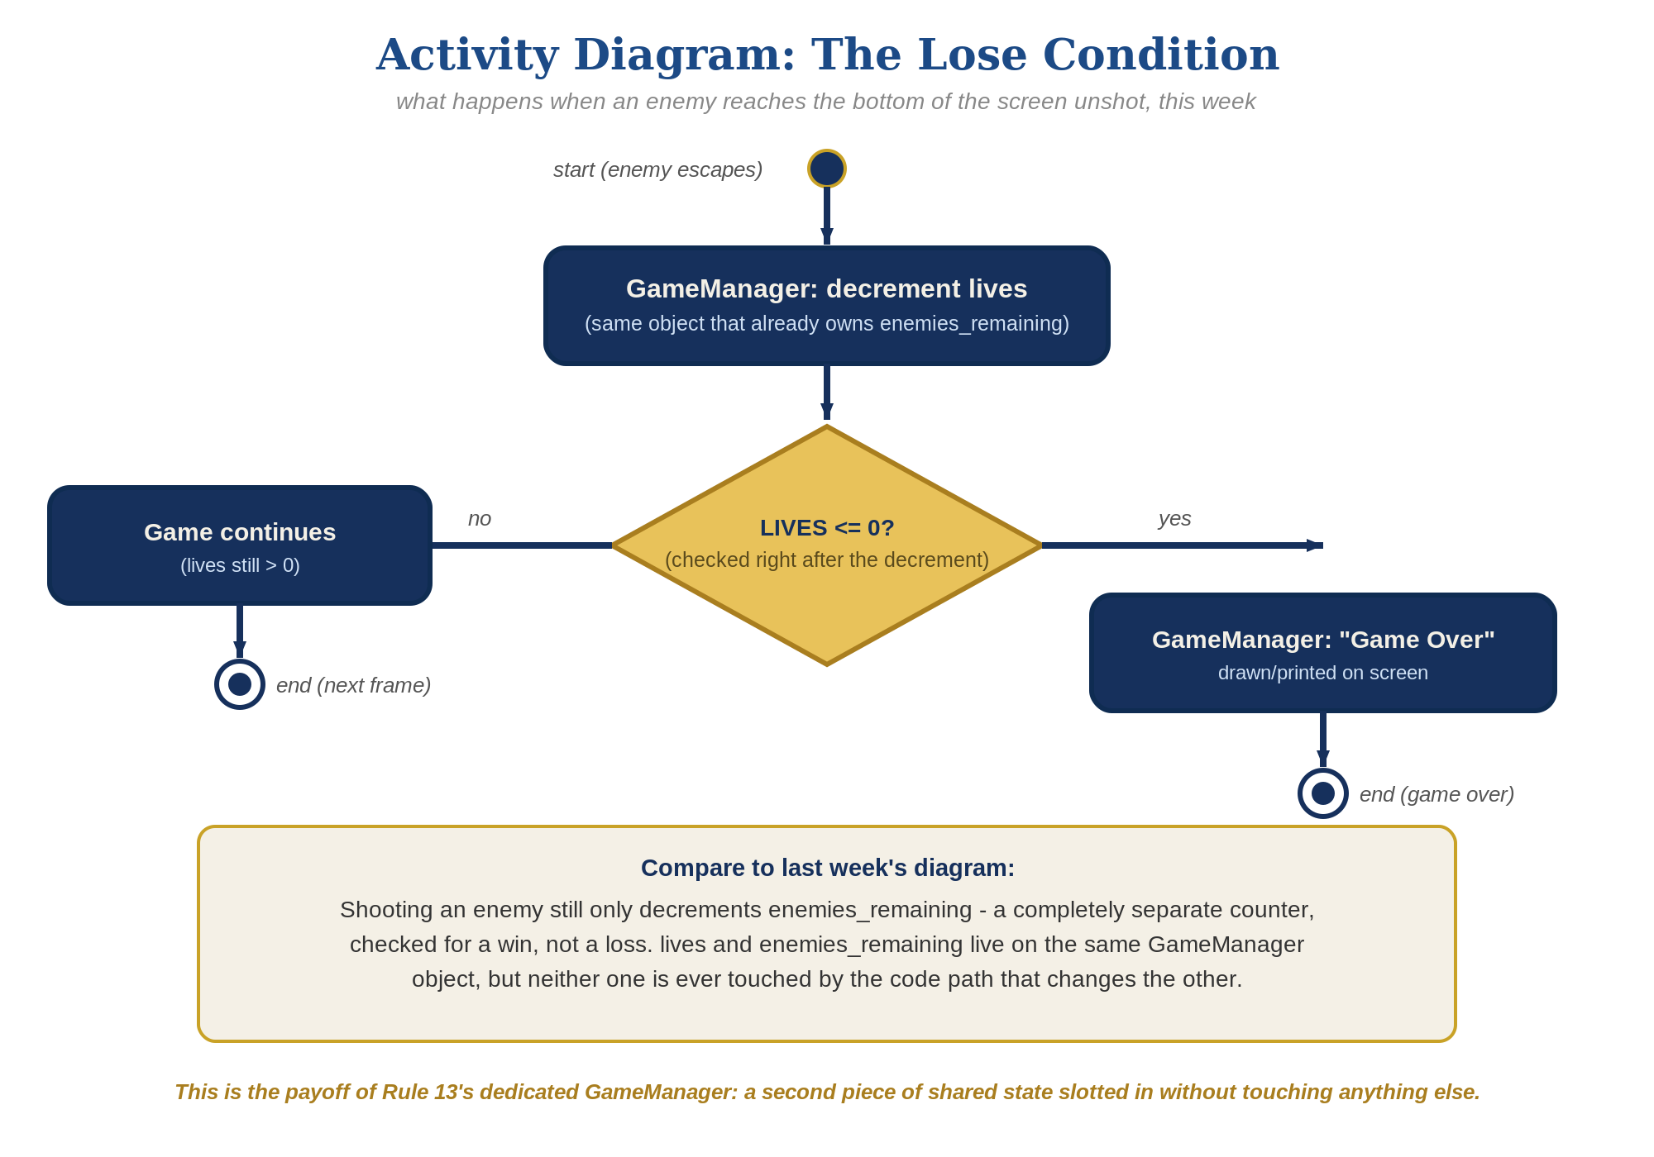
The lose-condition logic behind this week's exercise - the same shape in every engine, whatever the exact code or blocks look like.
- Add lives=3 near the top of your code, alongside enemies_remaining.
- In the enemy-drawing loop's escape branch (where you set e.alive=false for reaching the bottom), add the lives decrement (code below).
- At the bottom of TIC(), add an if check that calls print("Game Over", ...) when lives reaches 0, alongside your existing You Win! check.
- Press Esc, type run, press Enter, then let all 3 lives run out by letting enemies escape unshot - "Game Over" should appear the instant the third one escapes.
Highlighted lines are new this week; everything else is code you already have.
lives=3
-- enemy movement/escape (drawing loop, revised):
for enemy_index=1,#enemies do
local enemy=enemies[enemy_index]
if enemy.alive then
enemy.ey=enemy.ey+0.3
if enemy.ey>136 then
enemy.alive=false
lives=lives-1
else
spr(3,enemy.ex,enemy.ey,0)
end
end
end
-- bottom of TIC(), alongside the You Win! check:
if lives<=0 then
print("Game Over",40,60,8)
end

Level 2 - Complete (Alpha/Beta)
Shooting an enemy never costs a life, and letting one escape never counts as a kill - the two counters stay completely independent.
- Shoot an enemy and confirm lives does NOT change - only the bullets loop's collision branch, and enemies_remaining, should be involved.
- Let an enemy escape and confirm enemies_remaining does NOT change - only the enemy-drawing loop's escape branch, and lives, should be involved.
- Confirm "Game Over" appears exactly once, exactly when lives reaches zero.

Level 3 - Refined (Ready to Publish) - pick any that interest you
- Visual: add a second print() call showing the current lives value every frame - a nice touch, though the full scoreboard-style UI is coming properly in Lesson 9.
- Sound: import the provided sfx_lifelost.wav and sfx_gameover.wav into two new SFX slots (TIC-80's Surf/import tools accept an external .wav) rather than designing new effects from scratch, then call sfx(slot_number) in the escape branch - the life-lost slot normally, the game-over slot instead when lives reaches 0, guarded so it doesn't replay every frame.
- Structure: the two loops from Lesson 7 stay separate - the enemy-drawing loop only ever changes lives, and the bullets loop only ever changes enemies_remaining. Resist the urge to merge them even though both touch the enemies table.

If Something's Wrong
- Lives decreases when you shoot an enemy: confirm the lives decrement is only in the enemy-drawing loop's escape branch, not accidentally added to the bullets loop too.
- "Game Over" never appears: confirm lives actually starts at 3 and that the e.ey>136 threshold is actually being reached for escaping enemies.
- "Game Over" and "You Win!" overlap on screen: adjust the Y coordinate in one of the print() calls (e.g. 60 instead of 50) so the two messages don't draw on top of each other.

Want More?
Student Resource List > TIC-80 section, or tic80.com

